New updates for MH reconciliation
Before starting the reconciliation, add a column “Deposit Number” to the GL data so that deposit transactions can be correctly matched with bank transactions. Please follow the steps given below: -
- Download the "Deposit_Register" report from "AR Manager – Payment".

- Open “YardiOne Dashboard” and click on: - Elevate - MH Manager -> AR Manager – Payment-> Live -> Reports -> Register Report -> Transaction Register Report and fill the information and click on Display
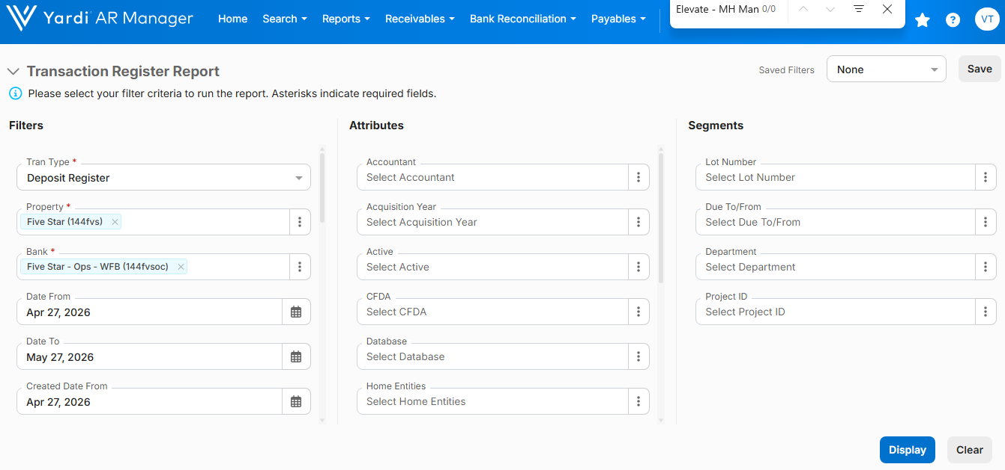
And the "Deposit_Register" report is generated.
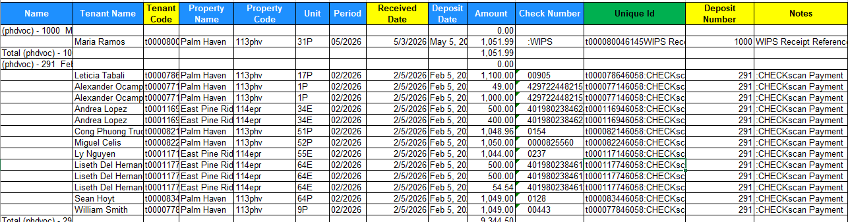

- In the Deposit Register, apply the "Text to Columns" feature to the four columns—"Tenant Code," "Received Date," "Deposit Number," and "Notes"—which are highlighted in yellow in the screenshot provided above.

- And to generate a unique ID in all rows, create a column before "Deposit Number" and use the formula "=CONCATENATE(“Tenant Code", "Received Date”, “Notes")" to create the unique ID.

Work in the GL file to create a Unique ID.
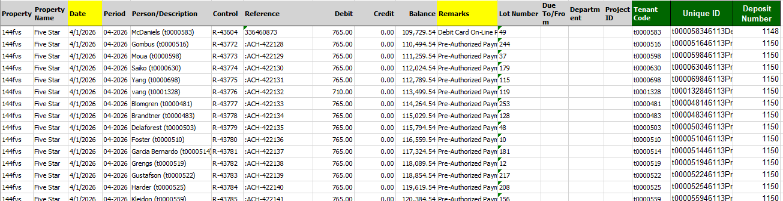
- In the GL file, apply the "Text to Columns" feature to the "Date" and "Remarks" columns; these columns are highlighted in yellow in the screenshot above.

- And to generate a unique ID for all rows, create three columns after the last column, "Project ID". (1. Tenant Code, 2. Unique ID, 3. Deposit Number)

- To generate the Tenant Code for all deposit entries, use the formula "=MID(E7,FIND("(",E7)+1,8)" in the "Tenant Code" column; see the screenshot below.
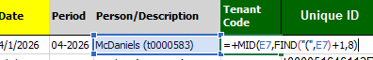

- After generating the Tenant Code, generate a Unique ID for all deposit entries, and use this formula "=CONCATENATE(“Tenant Code", "Date”, “Remarks")" in the “Unique ID” column; see the screenshot below.
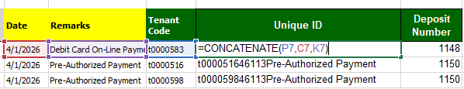

- After generating the Unique IDs in the GL file, use the formula `=VLOOKUP(Q7,'[Deposit_Register_May_PHdavieMH.xlsx]Deposit_Register'!$L$13:$M$33,2,0)` in the "Deposit Number" column to generate the deposit numbers for all deposit entries. see the screenshot below.
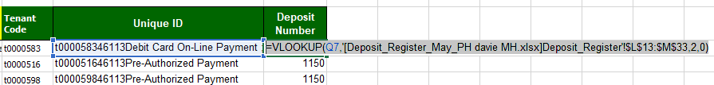
- Remove all letters and special characters from the deposit number; use only digits.
Example: - (ACH-RC 37075 – use only 37075, CC-989 – only 989, ACH-900 – use only 900)

S.No. | Transaction Type | Bank Side Transaction's Description | With | Deposit Number | GL Side Transaction's Description
1 | Deposit | LAKESHOREMANAGEM Settlement |  | Number | Online Payment - EFT
 |  |  |  | Number | Pre-Authorized Payment
 |  |  |  | Number | WIPS Receipt
 |  |  |  | Number | NSF receipt
 |  |  |  | Number | :CHECKscan Payment
Please apply for above transactions: - If bank deposit transactions match the corresponding GL deposit entries one and two business days prior to the transaction date, then additional transactions can also be matched correctly.
Use any Deposit Number 1234 for only one bank transaction, not for multiple bank transactions.
S.No. | Transaction Type | Bank Side Transaction's Description | With | Deposit Number | GL Side Transaction's Description
2 | Deposit | YARDI CARD DEP |  | Number | Credit card on-Line Payment
 |  |  |  | Number | Debit card on-Line Payment
 |  |  |  | Number | Recurring Debit Card Payment
Please apply for above transactions: - If bank deposit transactions match the corresponding GL deposit entries 4 and 6 business days prior to the transaction date, then additional transactions can also be matched correctly.
Use any Deposit Number 1234 for only one bank transaction, not for multiple bank transactions.
S.No. | Transaction Type | Bank Side Transaction's Description | With | GL Side Transaction's Refrence | GL Side Transaction's Description
1 | Withdrawal | Check |  | Number | Check (Same check number)
2 | Withdrawal | Intellipay Billing |  | Convenient Payments | Description begin with or contains Convenient Payment
3 | Withdrawal | LAKESHORE EMPLOYMENT |  | Number | LSE (v0000665)
Please apply for above transactions: - If bank Withdrawal transactions match the corresponding GL Withdrawal entries 1 and 3 business days prior to the transaction date, then additional transactions can also be matched correctly.

